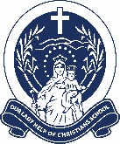
Our Lady Help of Christians School Uniform

UNIFORM  Formal Uniform  3 days/week  Sports Uniform  2 days/week | Boys - Formal Uniform | Boys - Sports Uniform | Girls - Formal Uniform | Girls - Sports Uniform
 |  | 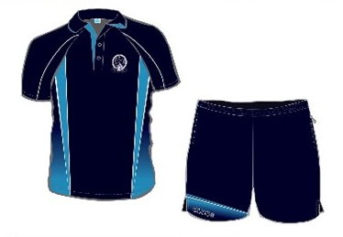  Gender neutral |  | 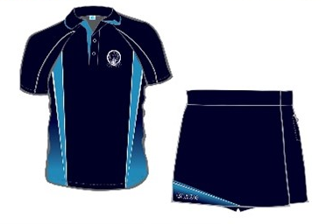  Gender neutral
HAT | Bucket hat with school logo |  | Reverse side of bucket hat
SHOES | Plain black joggers with black laces or black velcro must be worn with both the formal and sports uniform.
SOCKS | Navy crew socks (not knee high). Socks must be visible above shoes.
OTHER | JACKET |  | LONG PANTS
 |  |  | Minimal Stock Held

HAIR
It is an expectation that student haircuts conform to the following:
Hair should be neatly cut, and maintained at all times
Undercut styles are not acceptable, nor are tracks or lines, dramatic layers are not permitted
Hair must not be shaved, nor extreme cut with clippers, number 2 is the shortest acceptable length
Hair should not be tinted, coloured or overly styled by use of hair products
Hair decoration should be kept to a minimum with navy blue or white ties only
Long / shoulder length hair is required to be tied back or plaited. This applies to males or females as it discourages head lice and is a recommended practice by Queensland Health

JEWELLERY
One pair of sleepers / studs in ears only. Chains and rings should be kept at home and not worn to school. Watches are allowed and a chain with a religious medal / cross is permitted. No other forms of ‘necklace’ are to be worn.

MAKEUP
No eye makeup or facial makeup is to be worn. Nail polish is not permitted.

UNIFORMS CAN BE PURCHASED FROM UNIFORM LINK IN MANUNDA

